CSE301 Biocomputation, 2016
Week 5 Tutorial Exercises on MLP

Q1. What is the purpose of momentum in back-propagation learning? Briefly explain how this purpose is achieved.

The purpose of the momentum term in the BP update rule is to reduce oscillation of the weights and improve the convergence of the algorithm. This is achieved by adding a fraction of the change in weights in the previous iteration to the current change. If the previous and current changes are in the same direction then the net change is larger. If the previous and current changes are in the opposite directions then the net change is reduced.

Q2. Briefly describe the cross-validation based early stopping criteria for neural network learning. What are its benefits.

- Divide the training dataset into a estimation and a validation dataset
- Train the network on the estimation dataset
- After every fixed number of epochs of training, test the network on the validation dataset
- Stop the training when the validation error starts to increase (while the estimation error continues to decrease)

This approach helps prevent overfitting of the network to the training data. In other words, the use of this approach will improve the generalization property of the learned network.

Q3. State the requirements for a neural network for it to be a universal approximator.

- Two layer feedforward network with full inter-layer connectivity
- Hidden layer neurons use a non-constant, bounded, and monotonic activation function (e.g. the logistic function)
- The ouput layer neurons use a linear activation function
- Sufficient number of neurons in the hidden layer and sufficient training data

Q4. Describe the classification/decision rule for a (a) single-layer perceptron, and (b) multi-layer perceptron. Assume a general k-class problem where k > 2.

- Single-layer perceptron uses the threshold activation function.
For a k-class problem, ceiling(log₂k) output neurons are needed.
Decision rule: class j = base 10 of (binary output) + 1

(b) For a k-class problem, k output neurons are needed.
Decision rule: If neuron j has the maximum output then class is j

Q 5 In the Back-Propagation learning algorithm, what is the object of the learning? Does the Back-Propagation learning algorithm guarantee to find the global optimum solution?

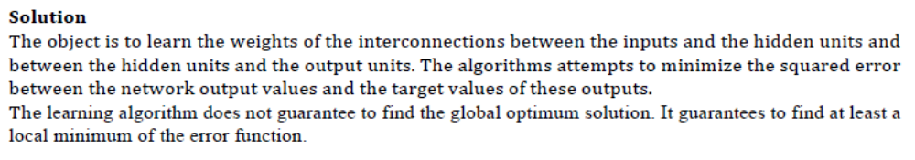

Q 6. Consider a two-layer MLP that has the topology shown in the figure.
- X1 and X2 are the two inputs.
- Z1 and Z2 are the two hidden neurons.
- Y is the (single) output neuron.
- wi, i=1..4, are the weights of the connections from the inputs to the hidden neurons.
- wj, j=5..6, are the weights of the connections from the hidden neurons to the output neuron.
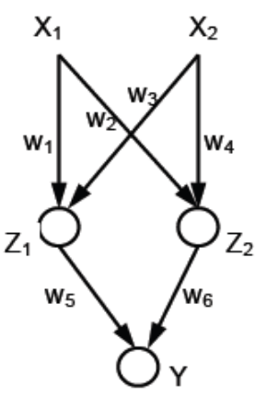
Explain the three phases (i.e., input signal forward, error signal backward, and weight update) of the first training iteration of the Backpropagation algorithm for the current network, given the training example: (X1=x1, X2=x2, Y=y).
Please use the following notations for the explanation.
• Net1, Net2, and Net3 are the net inputs to the Z1, Z2, and Y neurons, respectively.
• o1, o2, and o3 are the output values for the Z1, Z2, and Y neurons, respectively.
• f is the activation function used for every neuron in the network, i.e., ok=f(Netk), k=1..3.
• E(w) = (y - o3)² / 2 is the error function, where y is the desired network output.
• η is the learning rate
• δ1, δ2, and δ3 are the error signals for the Z1, Z2, and Y neurons, respectively

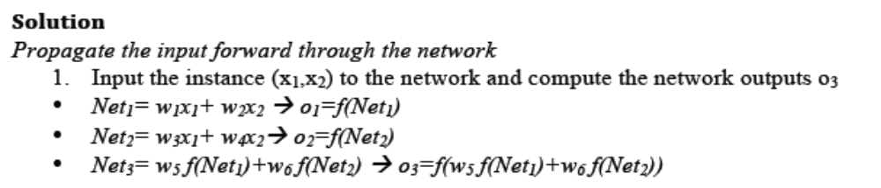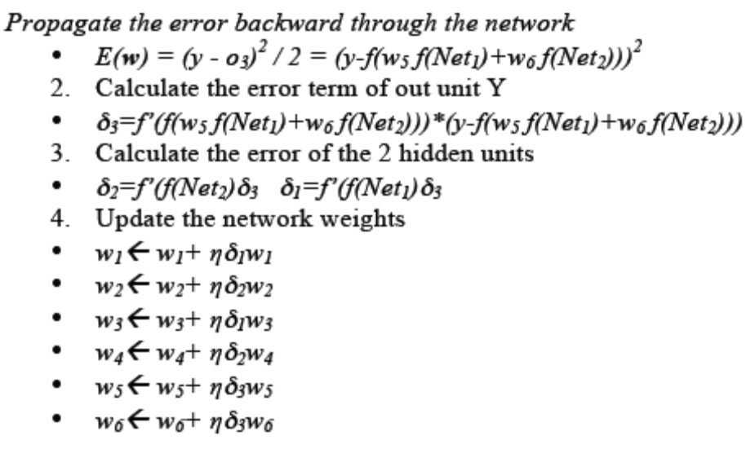

Q7. Apply the BP algorithm to find the new weights of a feedforward neural network after applying the input-output pattern ({1, 1}, 0). Assume the network has a single hidden layer with 2 neurons and all weights are initially zero All neurons use the logistic activation function.

Input, x = [1, 1]; Weights, w = [0, 0]
Output of the hidden layer
y₁ = φ(0) = 0.5
y₂ = φ(0) = 0.5
Output of the output layer, y = φ(0) = 0.5
δ = (d-y)y(1-y) = (0 – 0.5)*0.5*0.5 = -0.125

New weights for hidden to output layer
w₁ = (0.1) δy₁ = 0.1*-0.125*0.5 = -0.00625
w₂ = (0.1) δy₂ = 0.1*-0.125*0.5 = -0.00625
w₀ = (0.1) δy₀ = 0.1*-0.125*1 = -0.0125

New weights for input to hidden layer
δ₁ = δ₂ = 0.5(1-0.5)*-0.125*0 = 0
W = 0 (since delta is zero, so change occurs)

Q8. Consider a two-layer feedforward network with two inputs, one hidden neuron, and one output neuron. All neurons use the logistic activation function. Use the BP algorithm with momentum to update the weights of networks after each of the training examples {(1, 0), 1} and {(0, 1), 0}. Assume all weights are initially equal to 1, η = 0.2, and α = 0.9. Show your working.

Weights from input to hidden layer, w⁽¹⁾ = [w₀ w₁ w₂]^{T}
Weights from hidden to output layer, w⁽²⁾ = [w₀ w₁]^{T}
Initially all weights are equal to 1.

Example {(1, 0), 1}
x = [1 1 0]^{T}
v⁽¹⁾ = x^{T}w⁽¹⁾ = 2
y₁⁽¹⁾ = 1/(1+exp(-2)) = 0.8808
v⁽²⁾ = y^{(1)T}w⁽²⁾ = [1 0.8808]^{T}[1 1] = 1.8808
y⁽²⁾ = 1/(1+exp(-1.8808)) = 0.8677

Hidden to output layer
δ⁽²⁾ = (d-y)*y(1-y) = (1-0.8677)*0.8677*(1-0.8677) = 0.0152
∆w⁽²⁾ = α∆w⁽²⁾ [previous] + η δ⁽²⁾y⁽¹⁾ = 0+0.2*0.0152*[1 0.8808]
= [0.0030 0.0027]
w⁽²⁾ = [1.0030 1.0027]^{T}

Input to hidden layer
δ⁽¹⁾ = y(1-y)* δ⁽²⁾*w₁⁽²⁾ = 0.8808*(1-0.8808)*0.0152*1 = 0.0016
∆w⁽¹⁾ = α∆w⁽¹⁾ [previous] + η δ⁽¹⁾x = 0+0.2*0.0016*[1 1 0]
= [0.00032 0.00032 0]
w⁽¹⁾ = [1.00032 1.00032 1]^{T}

Example {(0, 1), 0}
x = [1 0 1]^{T}
v⁽¹⁾ = x^{T}w⁽¹⁾ = [1 0 1]T[1.00032 1.00032 1] = 2.00032
y₁⁽¹⁾ = 1/(1+exp(-2.00032)) = 0.8808
v⁽²⁾ = y^{(1)T}w⁽²⁾ = [1 0.8808]^{T}[1.003 1.0027] = 1.8862
y⁽²⁾ = 1/(1+exp(-1.8862)) = 0.8683

Hidden to output layer
δ⁽²⁾ = (d-y)*y(1-y) = (0-0.8683)*0.8683*(1-0.8683) = -0.0993
∆w⁽²⁾ = α∆w⁽²⁾ [previous] + η δ⁽²⁾y⁽¹⁾ = 0.9*[0.003 0.0027]+0.2*-0.0993*[1 0.8808]
= [-0.0172 -0.0151]
w⁽²⁾ = w⁽²⁾ [old) + ∆w⁽²⁾ = [1.0030 1.0027] + [-0.0172 -0.0151]
= [0.9858 0.9876]^{T}

Input to hidden layer
δ⁽¹⁾ = y(1-y)* δ⁽²⁾*w₁⁽²⁾ = 0.8808*(1-0.8808)*-0.0993*1.0027 = -0.0105
∆w⁽¹⁾ = α∆w⁽¹⁾ [previous] + η δ⁽¹⁾x = 0.9*[0.00032 0.00032 0]+0.2*-0.0105*[1 0 1]
= [-0.0018 0.00029 -0.0021]
w⁽¹⁾ = w⁽¹⁾ [old) + ∆w⁽¹⁾ = [1.00032 1.00032 1] + [-0.0018 0.00029 -0.0021]
= [0.9985 1.0006 0.9979]^{T}

